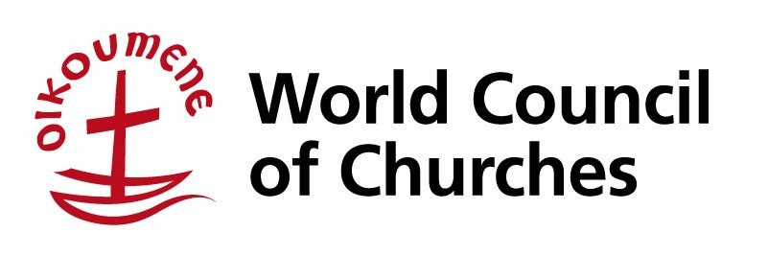

Stewards Programme
12- 25 March, 2020
Geneva, Switzerland

What is the WCC Stewards Programme?
The Stewards Programme brings together a dynamic and diverse group of young people from all over the world from 12th to 25th March 2020 (inclusive of travel dates). At the Central Committee meeting, the Programme will host 20 young people from different backgrounds, churches and regions. As a diverse community, stewards bring their faith, experiences and visions to an ecumenical experience of togetherness and friendship. Being a steward will challenge you, will foster your involvement and participation, and it could change your life. The Stewards Programme will be involved in: an on-site ecumenical formation and work at the Central Committee meeting.

Work, pray and sweat
Stewards arrive to Geneva a few days prior to the Central Committee Meeting proper to learn about the ecumenical movement. The work done is often exhausting, intense and under pressure of short deadlines. The main areas of tasks to be carried out are: floor management, documentation, communications, interpretation, worship and other tasks such as general administration, sorting mail, delivering messages, etc.

Financing
WCC will be responsible for board and lodging expenses during the programme and will provide some pocket money. Travel costs to and from Geneva are the responsibility of the steward, except in cases where subsidy is granted. Please see last page of application form for details.
All stewards who are granted partial travel assistance are expected to make a financial contribution towards their travel expenses. The purpose of the contribution is to allow more young people to participate in the programme, to strengthen the commitment of the participants, and to encourage the ownership of the programme by the participants and their churches and organisations.

Criteria
Stewards are young people between the ages 18 and 30 years old. English is the working language of the programme. Stewards need to be prepared to endure an intensive programme of activities and long, tiring work days. Working hours are irregular, and often special programmes are planned after work for the stewards. Patience, ability to work with people from other countries and cultures, and a willingness to work together as a team, are essential. The deadline for application is December 5, 2019.

Checklist
All completed applications require the following documents. Make sure you have them ready and in order before sending to our office. Only completed applications will be considered.
- Curriculum vitae/resumé
- Two (2) recommendation letters
- One from your church
- One from an ecumenical body
- A copy of either
- Passport*
- Identity card
*(Make sure your passport is valid six months from June 2018 onwards. If you don’t have a passport yet, if accepted to the Program, you are required to acquire it by February or March, especially if you need a visa to come to Geneva.)
Passport photo

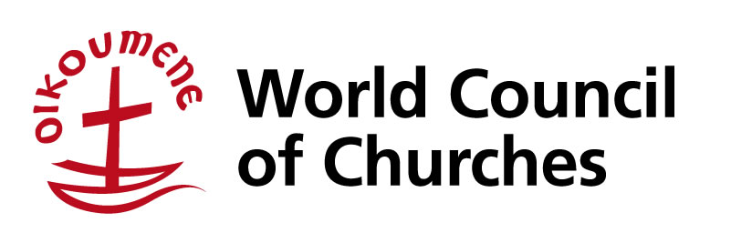
Steward Application Form
Please type or write clearly (in English). A completed application form may be sent along with the required enclosures by e-mail or printed and sent by post or fax. Due to the volume of applications normally received, we cannot acknowledge receipt of each individual application. Thank you for your patience and understanding.
1. Personal information
Title:  (Mr, Ms, Rev., etc.) | Family/surname:  (as in passport)
First/given name/ (s):  (as in passport) | Maiden name:  (if applicable)
Sex:  female male | Civil status: single married  others, please specify
Date of birth:  (day/month/year) | Town and country of birth:  (as in passport)
Belong to an Indigenous Peoples Group  yes no | If yes, please specify your people/tribe/Ethnic Group/nation
Nationality:  (as in passport) | Full name of passport country:
Passport number: | Place of issue:  (city, country)
Date of issue:  (day/month/year) | Valid until:  (day/month/year)
Faith community:
(full name of national church/diocese/denomination)

2. Contact information
Street address:

Postal/Zip code:  (if applicable) | City:
State (if applicable): | Country:
Telephone:  (country code, area code, #) | Mobile:  (country code, area code, #)
E-mail address: | Skype, Hangouts, Whatsapp account:  (for possible interview purposes)
3. Language
Mother tongue:
Other languages:
(please note proficiency level)
4. Other information
Current profession or occupation:
(If student, please specify field of study)
Ecumenical experience:

Other relevant information that should be taken into account in considering your application:

Special needs:
(Person With Disability, medical condition, dietary needs, etc.)
How did you find out about the Stewards Programme?
5. Essays Please answer the following on separate sheets (minimum of 300 words for each response):

Describe yourself. Include your involvement in youth work with your church and ecumenical bodies at a local, national, regional, or international level.

Name three issues and concerns that young people face in your country, in the order of priority. Explain each.

If selected as a steward, in what way/s will you contribute to the Program? In your home context?
I testify that the information I have given in this form is true and accurate and that, if accepted, I agree to abide by the conditions governing the World Council of Churches.
Date: | Signature:

travel coverage

To be completed by residents of Australia, New Zealand, North America, South Korea, and Western Europe: (Please put an “x”sign next to the statement below)
[ ] I confirm to cover my full travel expenses, if selected.

To be completed by residents of other Asian countries, Africa, Caribbean, Central and Eastern Europe, Latin America, Middle East, and the Pacific (Please put an “x” sign to one of the statements below)
[ ] I confirm to cover my full travel expenses, if selected.
or
[ ] I confirm to cover part of my travel expenses in the amount of USD_____, if selected.*
*We encourage the selected stewards, who request for partial travel assistance, to raise a goal of USD 200.00 or more contribution towards their travel expenses.

Please remember to enclose the following:
- Recent curriculum vitae/ resumé
- Two (2) letters of recommendation from your
- Church
- Ecumenical body
- A photocopy of: passport or identity card

I confirm that I will stay for the full duration of the Stewards Programme.
I understand that the WCC will provide accommodation, food, and small amount of pocket money for the period of the programme. Any other expenses, including passport and visa(s) costs, and related expenses such as vaccinations, luggage insurance or telecommunication costs, are my own responsibility.
I commit to contribute to the work of my church/National Council of Churches/Ecumenical Youth Organization after the WCC Stewards Programme and write a summary of the project for the WCC Youth Engagement in the ecumenical movement.
Date: | Signature:

Send your application by post to:
World Council of Churches
Youth Engagement Office
150, route de Ferney - PO Box 2100
1211 Geneva 2, Switzerland
Tel: +41 22 791 6209
Fax: +41 22 710 2057

Or send it electronically to :
Email Subject : Stewards Programme- (name)
E-mail: Youth@wcc-coe.org

Only COMPLETED APPLICATIONS, accompanied by the mentioned enclosures and received on time will be considered. Please do not send your application more than once.
Deadline: December 5, 2019

