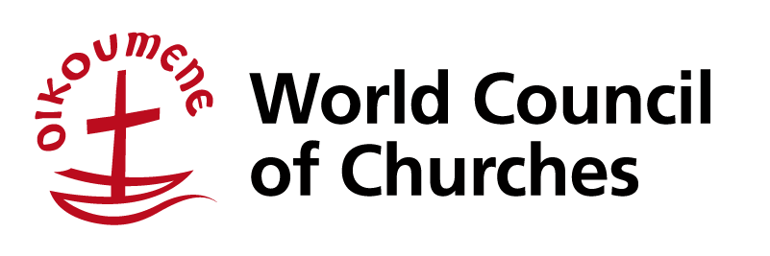
Title of Webinar: “Sustainable Food Systems to Overcome Hunger”
8 October 2021, New York 09:00-11:00; Geneva, Johannesburg 15:00-17:00, Nairobi 16:00-18:00, New Delhi 18:30-20:30, Bangkok 20:00-22:00
CONCEPT NOTE and PROGRAMME
Objectives for the Webinar:
- Analyse with feedback on the UN Food Systems Summit and the process leading to the summit.
- Discern key lessons from the process for Food Systems transformation.
- Discuss the role of youth in developing food systems.
- Reflecting on Christ’s teaching regarding sharing justly and equitably in the contexts of food systems.
Target Group/s: Youth from member churches and ecumenical partners, church leaders, Faith-based farmers, fisherfolk, pastoralists and advocates. ________________________________________________________________________________
Please register for the event via the following link:
https://us02web.zoom.us/meeting/register/tZ0udeitqTsjH9yHRrQltWxuvNvjGC28LIll
Brief description:
The webinar will provide an opportunity for critical analysis and feedback on the UN Food Systems Summit process and summit. (Pre – Summit took place in July and the Summit on 23rd September). The Webinar will have a substantial session for discussion in breakout rooms and and feedback. The scene for the discussion will be set by key input from expert voices in the faith context. As a theological input there will be reflections on Christ’s teaching regarding sharing justly and equitably in the different contexts and realities, within which food systems are developed and maintained. A youth discussant and Agripreneur, will address the role of youth in developing food systems to overcome hunger considering science and traditional wisdom. The session will be moderated by Young Christian activists and entrepreneurs.
Speakers
Opening remarks: Dr Agnes Abuom, Moderator, World Council of Churches.
Resource persons
- Ms Winnifred Mailu, Christian AID
- Mr Andrew Bartlett Kang, PC USA Hunger Programme
- Mr Andrew Schwartz, Director of Sustainability and Global Affairs, Centre for Earth Ethics
- Rev Nicta Lubale, Secretary General, Organisation of African Instituted Churches
- Mr Francis Kamau, Agripreneur, Kenya
Co Moderators- Ms Katlego Mohuba (South Africa) and Mr Tsiry Nantenaina (Madagascar)
Background
The United Nations Secretary-General's convening the Food Systems Summit in 2021 aimed to empower people to leverage food systems as accelerators of progress to realise the vision of the 2030 Agenda for Sustainable Development. The summit and the intensive process leading up to it, has had multisectoral engagement, and has been significantly influenced by agribusiness corporations, and hence boycotted by the many global social movements such as La Via Campesina and the World Forum of Fisher Peoples and the Civil Society Mechanism of the Committee for Food Security. But several Faith based organizations, including WCC, and several community-based organizations did participate and contributed to the activities and dialogues. The faith communities engaged in the process presented a ‘Interfaith Reflection and statement’ at the UN Food Systems Summit. The event is reaching out to you to update you and to receive your insights, for you to share in the analysis, and help discern key lessons from the process for Food Systems transformation. The discussions from the theological and youth perspectives aim to anchor the discussions, guiding us to move forward, in a relevant manner.
Time allocation | Agenda item
5 | Introduction to the Webinar: Dr Manoj Kurian, Coordinator, WCC- Ecumenical Advocacy, Ms Joy Eva A. Bohol, Programme Executive, Youth Engagement, WCC. (Information will also be shared on Weekend of Prayer and Action against Hunger, and the Youth for Life-giving food, agriculture, and fisheries network)
5 | Opening remarks & Prayer: Dr Agnes Abuom, Moderator, World Council of Churches.
25 | Part 1: Feedback and analysis of the Food Systems Summit process and summit.  Moderator: Ms Katlego Mohuba (South Africa)  - Ms Winnifred Mailu, Christian AID.  - Mr Andrew Schwartz, Director of Sustainability and Global Affairs, Centre for Earth Ethics.  - Mr Andrew Bartlett Kang, PC USA Hunger Programme.
2 | Instructions for Breakout Session
50 | Part 2: Parallel Breakout Sessions:  Each break out room will have a maximum of 8 participants, with preassigned moderators and note-takers  Questions-
30 | Part 3: Feedback  Moderator: Mr Tsiry Nantenaina (Madagascar)  - Report back from different breakout Sessions -15 minutes  Discussants:  - Rev Nicta Lubale, Secretary General, Organisation of African Instituted Churches- Christ's teaching regarding sharing justly and equitably in the contexts of food systems.  - Mr. Francis Kamau, Agripreneur, Kenya- Role of youth role in developing food systems.
3 | Wrap up/Closing
Summary
Title of Webinar: “Sustainable Food Systems to Overcome Hunger”
8 October 2021, New York 09:00-11:00; Geneva, Johannesburg 15:00-17:00, Nairobi 16:00-18:00, New Delhi 18:30-20:30, Bangkok 20:00-22:00
The webinar will be providing feedback and analysis of the UN Food Systems Summit and the process leading to the Summit from expert voices in the faith context and help discern key lessons from the process for Food Systems transformation. The Webinar will have a substantial session for discussion and feedback from all participants to contribute to the process. In addition, youth will lead the discussion on their role in developing food systems. A key discussant will also reflect on Christ's teaching regarding sharing justly and equitably in the contexts of food systems.

Please register for the event via the following link:
https://us02web.zoom.us/meeting/register/tZ0udeitqTsjH9yHRrQltWxuvNvjGC28LIll

